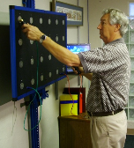

®

**Your local ERGOS®**

**assessment provider is:**

**McPherson Hospital**

**Corporate Health Services**

#### Simwork Logo Final TM

ERGOS® is manufactured by

**Simwork Systems**

**4101 Longfellow Ave., Suite 111**

**Tucson, Arizona 85714**

**(520) 795-2222**

**FAX (520) 795-4358**

***www.simwork.com***

**PRE-EMPLOYMENT HIRING SOLUTIONS**

Corporate Health Services provides the employer and with staffing solutions for their hiring needs. We document if the candidate meets your physical demands hiring standards objectively and in compliance with ADA and other regulations.

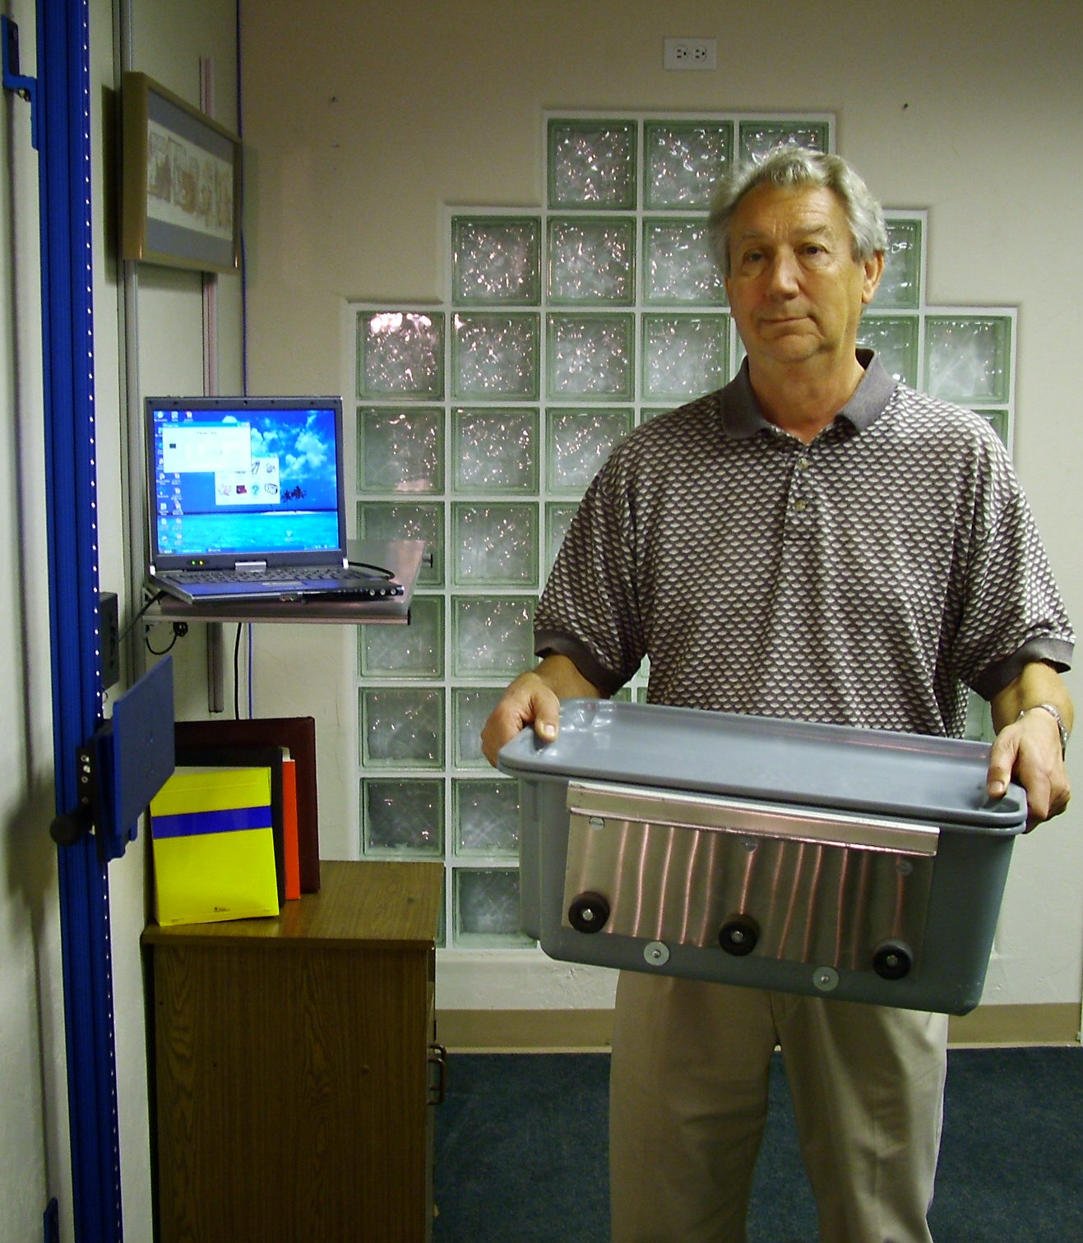

**Reduce Risk**

**Lower Injury Rates**

**Identify Qualified Staff**

**Comply With ADA Requirements**

Work Evaluation Services for Employers

At McPherson Hospital Corporate Health

Services, we do all the work required by the small and medium sized business when creating a quality hiring testing program. We are experienced in the development and operation of objective and fair physical demands measurement programs that identify qualified worker candidates.

Our knowledge of the requirements mandated by the Americans with Disability Act (ADA) enables us to construct a quality process that is objective and defendable if challenged. We work with the employer to create compliant record keeping that will not interfere with hiring goals or union contracts. McPherson Hospital Corporate Health Services can provide:

• Documented job standards via recorded analysis.

• Simplified records should an audit occur.

• ADA regulation training for your staff.

• Optional testing for employee candidates at plant.

• Defendable documentation of qualified workers.

McPherson Hospital

Corporate Health Services

823 North Main

McPherson, Kansas 67460

ph 620.504.5197

fax 620.504.5198

www.mcphersonhospital.org

McPherson Hospital

Corporate Health Services

**WE’VE WORKED WITH A DIVERSE CUSTOMER BASE. HOW CAN WE HELP YOU?**

**At McPherson Hospital Corporate Health Services, we understand your employee fitness testing needs. We are your community hiring experts.**

**McPherson Hospital’s Corporate Health Services employment testing deserves your company’s thoughtful investigation of its benefit. Our effective program reduces work place injury and injury costs. The Corporate Health Services employee work capacity testing program was designed to be defensible should a challenge occur. Test results are based on scientific criterion based data and conforms to EEOC Guidelines for implementation of the Americans with Disabilities Act (ADA).**







**CUSTOM TESTING SOLUTIONS**

We can provide employment testing solutions to any size business. Our assessment program can be customized for any size business small or large and has been used by Fortune 500 corporations.

**COMMUNICATION SOLUTIONS**

All testing is conducted with the ERGOS® Sapphire™ Work Assessment System. We conduct testing in English or Spanish languages for quality test consistency.

**SUPPORT SOLUTIONS**

We provide ongoing support after each assessment to assist the employer throughout the hiring process. Retesting follow-up is available should a challenge occur.

**EMPLOYEE MANAGEMENT**

Employers benefit by making certain that new employees are not at risk to themselves or co-workers when hired or returning after injury. This also helps identify aging workers who may no longer be safe. When a union contract is involved, our work capacities assessments help identify workers eligible for union disability pension benefits.

effective solutions for

your staffing needs

**RISK MANAGEMENT**

Employers benefit by matching the physical ability of the worker to the job he or she is being considered for. This reduces incidences of injury and employee turnover. Our testing process documents when the returning injured worker is fit for duty. This reduces the potential and complications of re-injury.

**State of the art employee work capacity testing services**

**we use the latest in hi-tech human performance equipment**

**Test incumbent employees safely in compliance with ADA guidelines**

**Test alleged workers’ compensation injuries objectively**

**Test returning workers as “fit for duty”**

**employment solUTIONS**

• Identify previous injuries

• reduce incidents of injury

• reduce injury costs

• Haero ut nutus accumsan.

• Genitus, te vero, erat.



